**Q-Tune: Alpha Test Plan**

Yenessa Avalos-Maldonado, Timothy Chiles, and William Trigg

**Expected Behavior**

1. The motors used should be able to be driven by a PWM signal from the Adafruit RP 2040 while being powered by the Adafruit RP 2040 or an external battery.
2. All components of the tuner (Adafruit RP 2040, LCD display, 6 servo motors, etc.) should be able to be powered by an external battery simultaneously.
3. 3D-printed tuning motor attachment should attach to the motor with ease and be secure as to properly tune the guitar peg.
4. The tuner should be able to tune all guitar strings to within 2 Hz of the actual in-tune frequency 80% of the time.

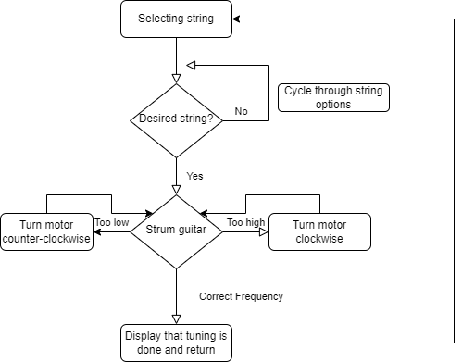

Figure 1: The overall flow of the expected behavior of the alpha build.

For each specified expected behavior, a test procedure for it is further outlined below

**Test Procedures**

1. For each servo motor on hand:
2. Attach 3D-printed tuning attachment to servo motor and to tuning peg of a guitar
3. Plug test power source into relevant wires of servo motor and Adafruit PWM pin into data line of motor
4. Run test code that tests motor turning clockwise, counter-clockwise, and stopping
5. Record whether motor turns and if it has enough torque to turn tuning peg of guitar
6. Repeat steps 1-4 with all potential power sources (3.3V, 5V USB, 3.7V Lipo battery, 4.5V and 6V (AA batteries)). Record suitable voltage/motor combinations for future use.
7. Determine the total power needed for our system and compare it to possible power from the batteries. Test different power sources by gradually adding components and examine how the system responds.
   1. Separate each component of our internal system into small measurable parts
   2. Measure the voltage and current of each component
   3. Using one component, add another component to it and remeasure the overall voltage and current
   4. Observe and record how the system behaves
   5. Repeat 3 and 4 until all the components are connected
   6. Determine the overall power needed for our system and compare it against possible battery options
8. For each 3D printed tuning attachment:
9. Attach it to the servo motor by sliding it onto the motor shaft and screwing in. Record the fit of the attachment (snug, loose, does not fit)
10. Slide the relevant end of the attachment onto the tuning peg of the guitar. Record fit of attachment on tuning peg
11. Run test code that turns the motor. Record whether motor successfully turns tuning peg
12. Repeat steps 1-3 for all tuning attachments on hand. Make qualitative assessment of tuning attachments to select the best candidate for future use. Make changes to CAD files and reprint if necessary
13. For each guitar string:
14. Manually turn the string’s tuning peg until the oscilloscope reports the string is at the desired starting frequency
15. Select the relevant string on the LCD and strum the string when prompted
16. Measure the frequency of the string with an oscilloscope once the tuner is finished tuning
17. Record the end frequency of the string. Repeat steps 1-3 until starting frequencies of in-tune frequency +/- 15 Hz, +/- 10 Hz, and +/- 5 Hz have been tested
18. Compile results, make adjustments to hardware/software, and repeat testing procedure until desired accuracy has been reached